Ti Tans Bank KYC System – Application Architecture
This document describes the application architecture of the Ti Tans Bank KYC System. The architecture is designed to provide a secure, scalable, and AI-driven Know Your Customer (KYC) process.

Architecture Overview
The system follows a layered architecture consisting of User Interface, Application Gateway, Backend Services, Data Layer, AI/ML Services, External Integrations, and Security components.
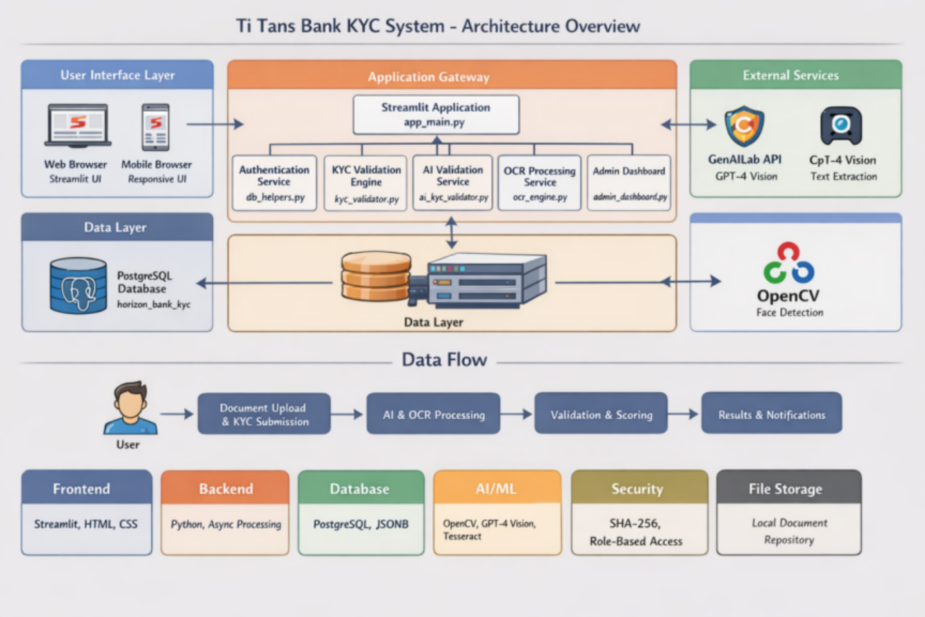

Key Architectural Layers

1. User Interface Layer
- Web and Mobile browsers using Streamlit UI
- Responsive interface for document upload and KYC submission

2. Application Gateway
- Central Streamlit application (app_main.py)
- Routes requests to authentication, OCR, AI validation, and admin services

3. Backend Services
- Authentication Service
- KYC Validation Engine
- AI Validation Service
- OCR Processing Service
- Admin Dashboard

4. Data Layer
- PostgreSQL database (horizon_bank_kyc)
- Stores customer data, KYC results, and audit logs

5. AI / ML Services
- GPT-4 Vision for document intelligence
- OpenCV for face detection and verification
- OCR using Tesseract / Vision APIs

6. Security Layer
- SHA-256 encryption
- Role-based access control
- Secure document handling

7. Data Flow
User uploads documents → AI & OCR Processing → Validation & Scoring → Results & Notifications

